
UNM HOSPITALS
2211 Lomas Boulevard, NE
Albuquerque, New Mexico 87106

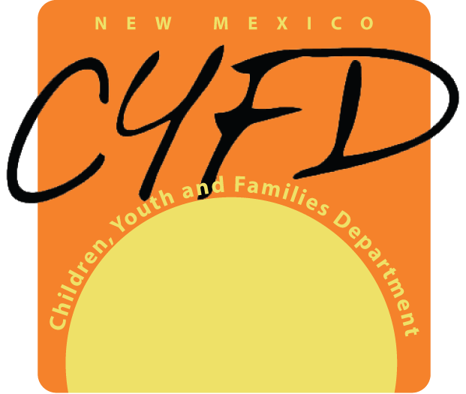

CHILDREN, YOUTH AND FAMILIES DEPARTMENT
- Paseo de Peralta
PERA Building
Santa Fe, New Mexico 87501
Bill Richardson Dorian Dodson
Governor Cabinet Secretary
__________________________________________________________________________
November 5, 2007
For Immediate Release
Contacts:
UNM Hospitals:
Cindy Foster, UNM Health Sciences Center Public Affairs Office
505-272-0260 CindyF@salud.unm.edu

CYFD:
Deborah Martinez, CYFD Public Relations Manager
505- 699-1828 Deborah.Martinez@state.nm.us

UNM Hospital Partners with CYFD
To Launch the First Permanent Heart Gallery in the US—
Saturday, November 10 at the Bill and Barbara Richardson Pavilion

Dedication Ceremony Features Entertainment and Dignitaries

Albuquerque, NM -- On Saturday, November 10, 2007, UNM Hospital and the New Mexico Children, Youth & Families Department (CYFD) will host a dedication ceremony for the first permanent Heart Gallery exhibit in the US. The celebration will take place from 1pm to 2pm in the lobby of the Bill and Barbara Richardson Pavilion of UNM Hospital at 2211 Lomas Boulevard NE in Albuquerque.

The Heart Gallery features beautiful portraits of children in the custody of CYFD who are in need of permanent homes. This acclaimed initiative was born in New Mexico and has become the model for Heart Galleries in almost every state in the nation.

CYFD Cabinet Secretary Dorian Dodson lauded this historic partnership. “This outstanding venue will capture the attention of hundreds of thousands of visitors each year, ensuring that the message about New Mexico’s foster children who are available for adoption is always in the public eye.”

"A permanent exhibit like this is a perfect fit for UNM Hospital and Children's Hospital of New Mexico," said Robert Katz, M.D. UNM Health Sciences Vice President for Clinical Affairs. "Our physicians and staff see so many kids who are having a hard time or in tragic circumstances and need a good home. This exhibit allows us the opportunity to participate in seeing some of those sad situations turned into happy endings, both for the children and for the people who want to welcome them into their homes and lives."

The dedication ceremony will include entertainment by Ballet del Fuego and inspirational words from the first Heart Gallery family, the Somervilles. News anchor Cynthia Izaguirre of KOAT-7 will emcee the event.

-30-

